**Bash Script/Cronjob Tasks**

1. Create a Bash script to check if a directory is available or not.

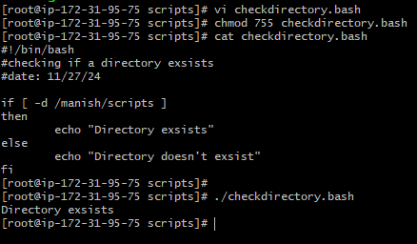

1. Create a Bash script which will create multiple files.

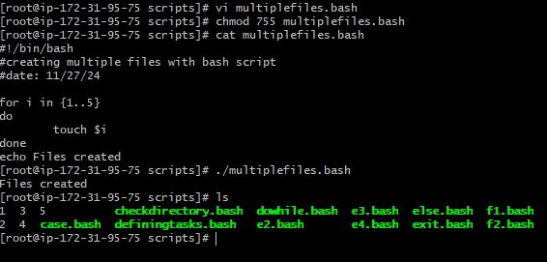

1. Create a Bash script to take backup of a directory.

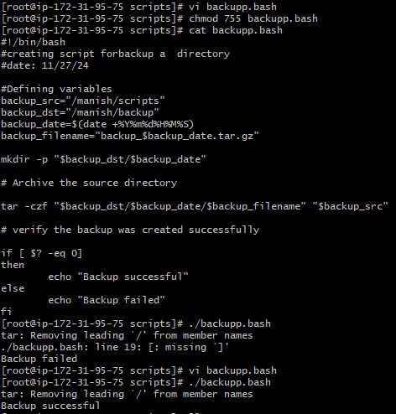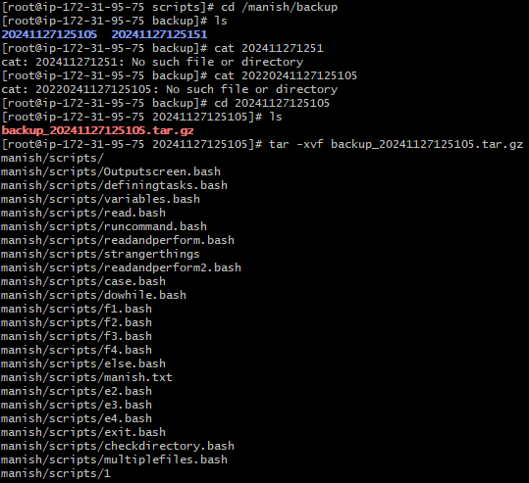

1. Create a Bash Script to install nginx in a ec2 server.

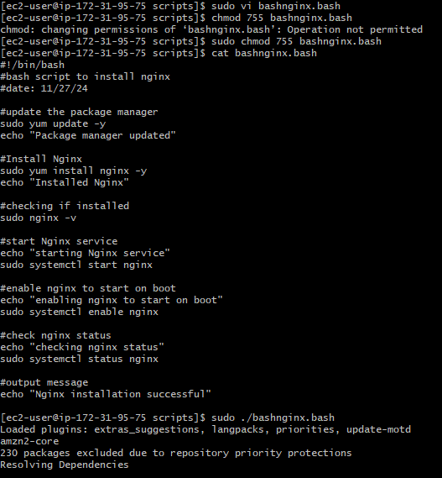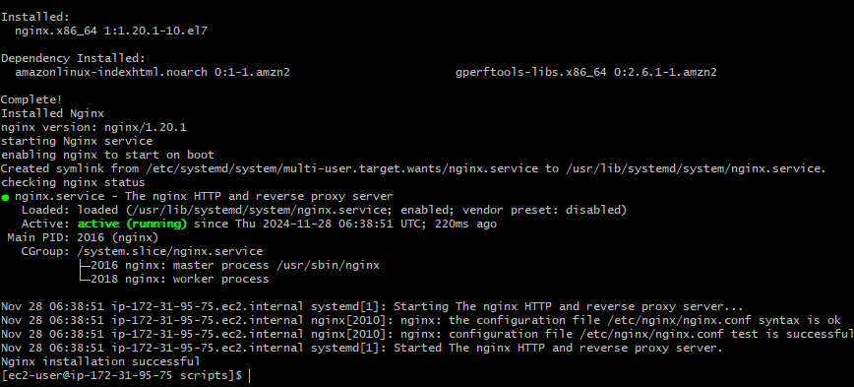

1. Create a Bash Script to install Apache Tomcat in ec2 server.

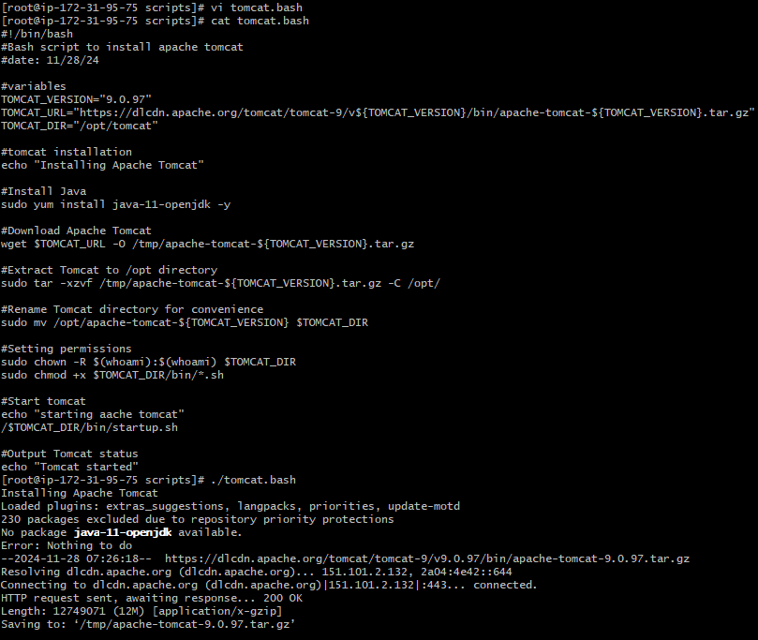

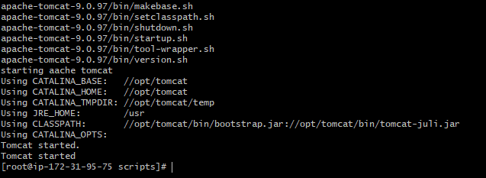

1. Create a Bash Script to check list if nginx service is running or not, if not running then script should start the service.

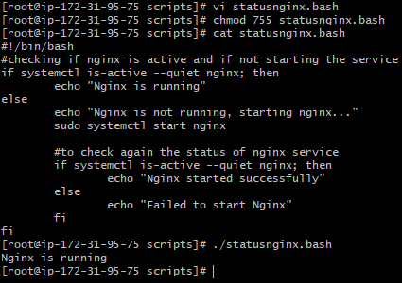

1. Create a Bash script for calculator.

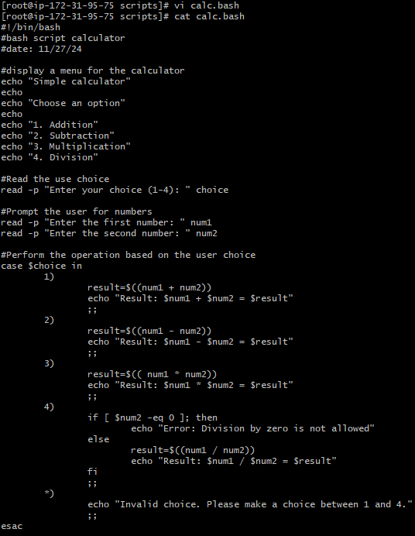

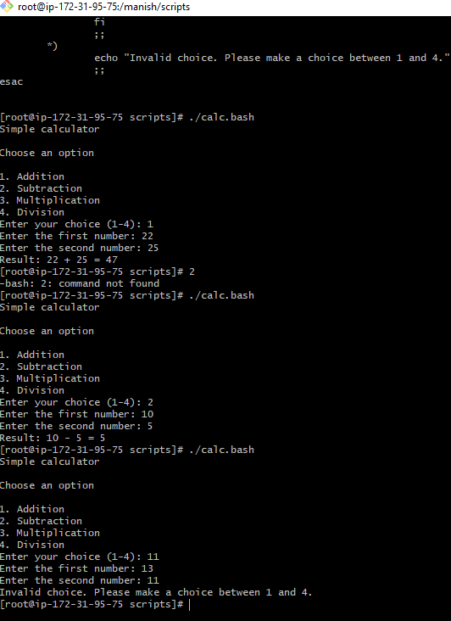

1. Create a Bash Script to check if directory is available or not, if not then create a directory.

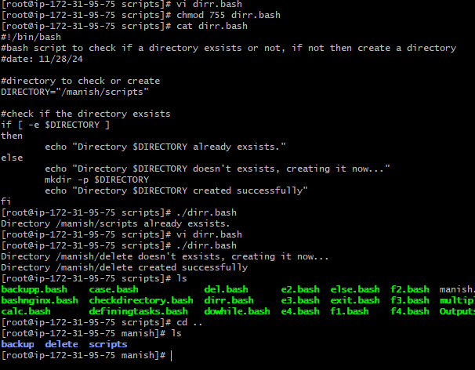

1. Create a Bash Script to delete 3 lines of a file.

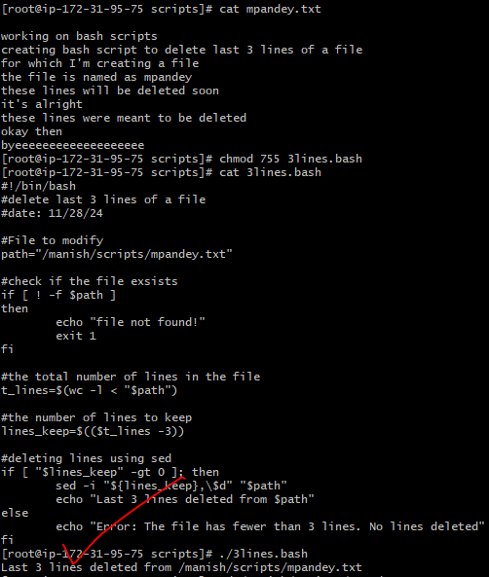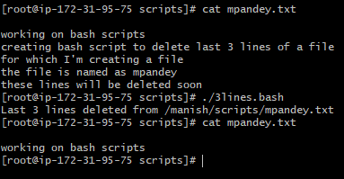

**Exercise Crontab Entries:**

1. April 5th Midnight



1. 5th of every November, Jan, June if it is a Thursday



1. At 05 and 27th minutes of 9,10,11 hours everyday

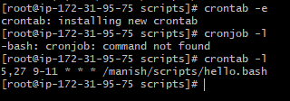

1. 34 min. of 9th hour on 15th Aug

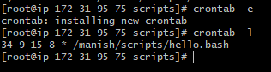

1. Every Midnight

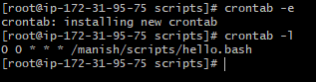

1. Every weekend (Saturday night 11:59)

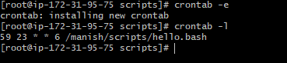

1. After every reboot

